GRANGE PARK HORTICULTURAL SOCIETY

**2017 COACH OUTING**

4TH June, 2017

We will be going to:

**KATHY BROWN’S GARDEN**

**There will be a guided tour of the garden followed by**

**Tea and Kathy’s Home-made cake**

Before going to the Garden we will have a

**Sunday Roast Lunch with Ice-cream dessert**

at

THE OLD SWAN, at Aston

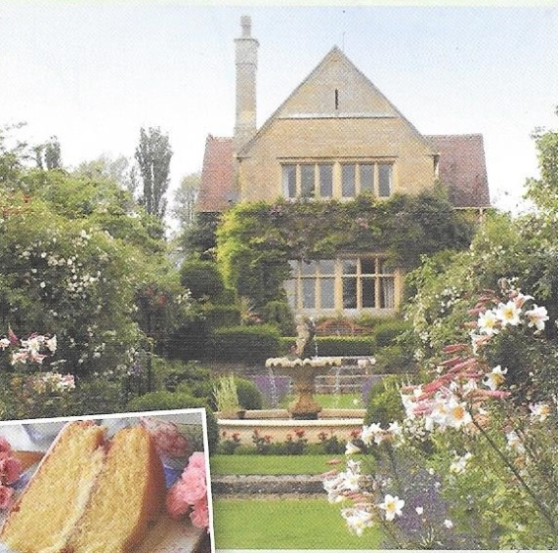 **Over the last 24years, Simon and Kathy Brown**

**have created the Manor House Gardens.**

**They began with the Cottage Garden then**

**they designed the Formal parterres to the east**

**with their clipped jury scene and rose arbours.**

**In 2015 a new entrance was cut into the top**

**Terrace. Gardens never stand still.**

**The formality remains but in more contemporary**

**style. Over the past twelve years a series of**

**Art Gardens have been developed, inspired by**

**Hepworth, Monet Mondrian and Hokusai.**

**The Rothko gardens rely on clipped hedges**

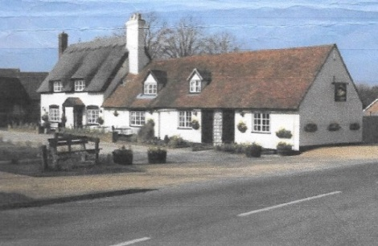 **and brooding reds and maroons.**

**Kathy’s interest in cooking and baking led to**

**The Edible flower border which provides a rich**

**larder for her afternoon teas.**

**The Old Swan is a 17th Century Coaching Inn.**

**John and Janet will welcome us to their home**

**full of antiques, oak beams and atmosphere.**

**You will have a choice of Roast Sirloin of Beef,**

**Leg of Lamb or Breast of Chicken. (Pre-ordered)**

**There will be a Vegetarian option.**

**This will be followed by Ice cream.**

**Drinks can be purchased at the bar**

**£34.75 per person**

**All gratuities included.**

**(£37.75 for non-members - includes optional membership)**

**Sold out but waiting list open**

**If you want to reserve places, please contact Evelyn**

**0208 363 4708 or** [**secretary@gphs.org.uk**](mailto:secretary@gphs.org.uk)

**£10 per person deposit required, or payment in full. Thank you**