Grange park horticultural society
Annual Sweet pea and rose show Regulations
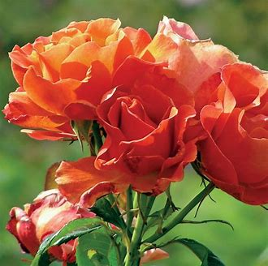
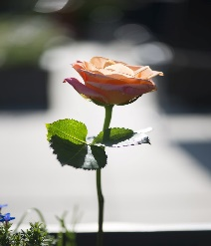

Example of ROSE single stem Example FLORIBUNDA single stem

- Entry forms to be delivered to the Secretary, Evelyn Craven, 5 Elmwood House
2 Crescent Road, EN2 7AR as early as possible but not later than 7pm on the
Thursday prior to the Show. Or emailed to secretary@gphs.org.uk
(Please note that entries submitted after this time may not be accepted)

- Exhibits must be staged between 9.30 am and 11 am on the day of the Show.
Exhibitors are requested to stage exhibits as early as possible.

- The Society will provide vases for all exhibits

- All exhibitors are asked to label their exhibits, as far as possible, with the name of
the variety. In close competition, the Judge will take this into consideration

- All exhibits must be made in the name of a paid-up member of the Society
(Except juniors under 14, who must be the child or grand-child of a paid up member)

- Exhibitors may only enter 1 entry in any class. Two or more persons may not compete separately in the same class with Sweet Peas from the same garden and/or allotment. If members of a household wish to share the credit and prizes, then the exhibits should be entered in joint names.

- All exhibits must have been grown by the exhibitor, who may have employed
labour for rough work only.

- Exhibits or Award cards must not be removed before the close of the Show at
4.30 pm. Items not removed at the end of the Show will be disposed of by the Committee.

- Judge’s sheets must not be removed and remain the property of the GPHS in case of disputed awards.

- The Committee, in consultation with the Judge, may withhold any award in any class, or make additional awards at their discretion.

- The RHS Show Handbook will be used by the Judge as a guide and the decision of the Judge must be regarded as final.

- Exhibitors to be responsible for placing and removing their own exhibits.

- Any contingency arising, not provided for in these Regulations, shall be subject to the decision of the Committee.
NOTE:
Points and certificates will be awarded for 1st, 2^{nd,} 3rd place, and highly commended.
GPHS TRADING HUT Vouchers will be awarded for highest, second highest and third highest points. Juniors will receive a small cash award for best in category.
Additional voucher will be given for Best in Show of both Sweet Peas and Roses

